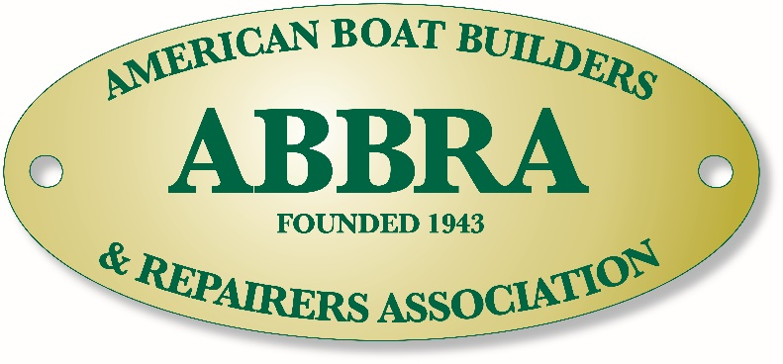

American Boat Builders and Repairers Association
Award Categories - Cast your ballot!

This is your chance to recognize our peers and colleagues for their outstanding service to the industry. This year’s categories include:

- Dennis Snow President’s Award – Awarded to the individual or company for outstanding contribution to the Boatyard and Repair Industry.

- Boatyard of the Year – ABBRA’s Boatyard of the Year award is given to the boatyard facility that demonstrates excellence in all facets of their company through commitment to customer service, quality workmanship, best business practices, industry standards, professionalism, workforce development, and positive vendor relations.

- Boat Builder of the Year - ABBRA recognizes the boatbuilding facility that through its commitment to innovation, sound engineering, quality workmanship, teamwork, and professional project management, has built a vessel that has been successfully launched and recognized as a significant contribution to the recreational yachting industry.

- Excellence in Customer Care – ABBRA recognizes the boatyard or repair facility that has built a successful business by consistently focusing on customer satisfaction.

- Excellence in Safety & Environmental Practices – Awarded to the boatyard or service facility that has made significant strides in creating a clean, safe and healthy facility for workers and customers.

- Commitment to Training – Awarded to the service or repair facility that has demonstrated a significant commitment to training and professional development for themselves and their employees.

- Excellence in Technology – Awarded to the service or repair facility that has developed or applied an advanced or innovative technology, system, or practice.

To cast your ballot, complete the next page then
scan and email your nominations to ABBRA at joy@abbra.org

ABBRA Awards Nomination Form
Please fill out, scan and e-mail to:
American Boat Builders and Repairers Association
Email: joy@abbra.org

From: ____________________________________________________________________________
Company Name: ___________________________________________________________________
Contact: __________________________________________________________________________
Address: __________________________________________________________________________
City: State: Zip: ____________________________________________________________________
Telephone: Fax: ____________________________________________________________________
E-mail:____________________________________________________________________________

Dennis Snow President’s Award  Name:__________________________________  Company:_______________________________  Telephone/e-mail:_________________________  Justification:_____________________________ | Boatyard of the Year  Name:__________________________________  Company:_______________________________  Telephone/e-mail:_________________________  Justification:_____________________________
Boat Builder of the Year  Name:__________________________________  Company:_______________________________  Telephone/e-mail:_________________________  Justification:_____________________________ | Excellence in Customer Care  Name:__________________________________  Company:_______________________________  Telephone/e-mail_________________________  Justification_____________________________
Excellence in Safety & Environmental Practices  Name:__________________________________  Company:_______________________________  Telephone/e-mail:________________________  Justification:_____________________________ | Excellence in Technology  Name:__________________________________  Company:_______________________________  Telephone/e-mail:_________________________  Justification:_____________________________
Please nominate one person for each category. For each nominee, provide name, company, and contact number/e-mail and a short justification (attach an additional sheet if necessary).

